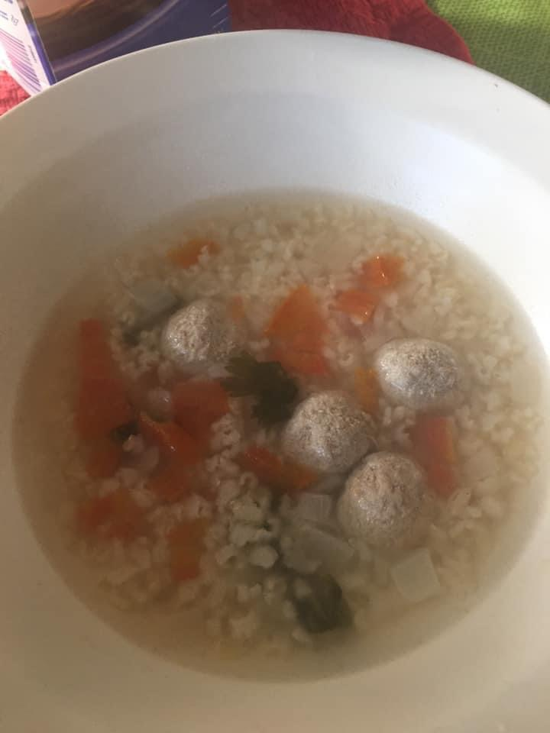
Albondigas ( Meatball Soup )
Ingredients: 2 fresh tomatoes
Cilantro
1 brown onion
1 pound of ground turkey
1 pound of brown rice
Wash hands and vegetables thoroughly.
Dice tomatoes and onion. Take the leaves off the stems of the cilantro until you have about a cup of cilantro.
In a 2 quart pot, fill with water three quarters. Place the pot on the stove and turn to high heat. Add onions, tomatoes, cilantro, and garlic powder (to your preferred taste).
Bring pot to a hard boil. Add the brown rice and let the pot boil for 20 minutes. Then bring to low heat and let simmer for 30 minutes.

After the rice is soft and cooked, set the pot to boil. While it heats up, roll ground turkey into ½- 1 inch in diameter balls.
Place rolled turkey balls into the cooked rice and let it cook for 15 - 20 minutes.
NOTE: Turkey will have a light color after it is cooked (unlike beef, which has a darker color). Season your albondigas with pepper and/or lemon to your desire.
Enjoy!

